**Experiment - 12**

**Objective :** Write a program to check leap year.

**Program :**

a=int(input())

if(a%4==0 and a%100!=0) or (a%400==0 and a%100==0):

print(a ," is a leap year")

else:

print("Not a leap year")

**Code :**

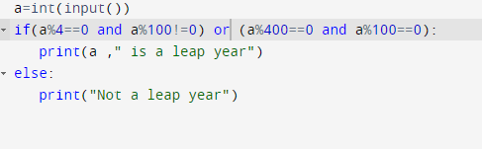

**Output :**

